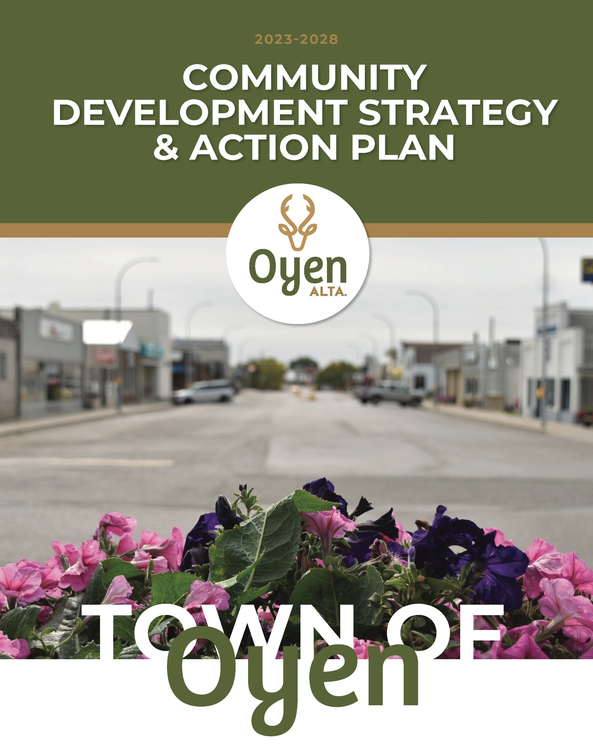

THE TOWN OF OYEN
In the heart of east-central Alberta, near the Saskatchewan boundary, lies Oyen, a town with a population just shy of 1,000. Oyen is a community rooted in agriculture, horticulture, and alternative energy, boasting a rich heritage and a forward-looking perspective. This Community Development Strategy has been developed to leverage these strengths, aiming to foster sustainable growth and enhance the quality of life for all residents. By embracing change, nurturing innovation, and drawing on the region’s collective assets, we seek to invigorate Oyen’s economy and ensure its resilience. Together, we will explore new avenues for business, encourage broad participation in our development efforts, and build a future where Oyen thrives and shines as a beacon of community spirit and prosperity.

VISION
The Town of Oyen is a thriving, safe, and caring community where residents and visitors live, work, and play. As a Municipality we strive:
- To be the central community “hub” in the region that residents and visitors come to for their personal and business needs.
- To be recognized for innovative projects and collaborative efforts in ensuring growth and sustainability in our rural community.

MISSION
The Town of Oyen provides excellent municipal services, infrastructure, and recreational opportunities for our communities’ families, seniors, and visitors. We achieve this by:
- Maintaining and improving our infrastructure
- Creating an environment that attracts and welcomes business, industry, and tourism
- Collaborating with other Municipalities, regional stakeholders and local groups on projects and initiatives that will benefit the Town
- Engaging our community residents through events, recreational opportunities, and local programs and services.

WHAT IS THE POINT OF A PLAN?
The Town of Oyen Council understands the crucial role of a unified Community Development Strategy and Action Plan in guiding the town towards sustainable growth and enhanced well-being. This strategic plan is designed as a roadmap, implementing the plan is a collaborative effort, inviting participation from residents, businesses, and regional partners. Its core objective is to foster an atmosphere ripe for business expansion, job creation, and economic stability, boosting all inhabitants' overall quality of life. The plan aims to unite the community around common goals, streamline project prioritization, and secure investments by laying out clear, achievable steps and focusing on efficient resource use. Ultimately, this strategic approach is about adapting to future challenges and opportunities, ensuring the community thrive and are resilient in facing social and economic shifts.
Where are we now?
Through community discussions, surveys, and five Community Cafes with groups from students to seniors, the residents honed in on what matters most to Oyen. From September 2022 to March 2023, about 250 people shared their ideas, discussing the following questions:
- How can the community sustain and grow our local businesses?
- How can we make Oyen a place where youth choose to stay and work as adults?
- How can we create a welcoming community for families at every stage, from settling in to enjoying retirement?

From the discussion, four core priorities that require strategic effort to improve and develop. They are:
- Business and Industry Development;
- Education;
- Agriculture; and
- Health.

After the community round tables discussions, Town Council added a fifth priority – responsible governance. All five priorities have separate strategies and action items, and they will be worked on consecutively.

OYEN’S COMMUNITY DEVELOPMENT STRATEGY & ACTION PLAN
Where do we want to go?
The following section outlines the five strategic priorities, the goal, and the corresponding actions as having been completed on or before April 2024, action that are in progress and those that are in future plans as community champions, resources and/or budget become available.
- BUSINESS AND INDUSTRY DEVELOPMENT

Goal:
Enhance the vibrancy of Oyen's business sector by retaining and expanding the existing business community in the town and its surrounding region.
Supporting local businesses will help establish a vibrant business community by ensuring they remain and strengthen. This process will involve establishing open channels for two-way communication through regular, structured engagement with business owners, the Chamber of Commerce and regional economic development organizations. This will enable the tailored development of strategies and allocation of resources to meet the specific needs of businesses, thus supporting their growth and attracting new investments. The ultimate aim is to bolster the existing business sector and ensure a welcoming environment for prospective investment.
How will we get there?

Strategies:
- Workforce development - provide support to local business needs through workforce development

- Entrepreneurship development - increase opportunities for start-ups, business training and mentorship.

- Business engagement - foster strong community relationships and participation in business development projects to ensure alignment with local needs and goals.

Business & Industry Development – Action Items
Wins - Completed 2023
- Participating in the Alberta Advantage Immigration Program (AAIP) as a designated economic immigration region that supports people seeking permanent residence in Alberta.
- Confirmed as a Designated community for the Rural Renewal Stream to welcome newcomers.
- Created a Newcomers’ page on the Oyen website, providing tools and resources to attract, retain, and integrate newcomers into the community.
- Completed an Employer and Employee Needs survey with Special Areas.
- Jointly developed the Return 2 Rural (R2R) Workforce Strategy and Action Plan for municipalities through the Special Areas Economic Development Office, led by Wanda Diakow.
- Launched the Welcoming Communities Committee in December 2023, with the intent to foster a welcoming and inclusive environment for newcomers.
  - We are actively responding to newcomer registrations online or at the Town office, offering meetings, advice, support, connections, and contacts through a committee member.
  - Providing online access to documents like the Terms of Reference, Guidebook, and an Ambassador Volunteer Application Form and recruiting volunteers for the committee.
- Expanded the Town’s online Business Directory, the increased marketing stimulates business-to-business (B2B) and business-to-consumer (B2C) awareness, networking, and spending. “Spotlight Sundays.”
- Cleared and repurposed in fall 2023, the former Old Hotel lot now is available for new business opportunities on Main Street.
- Completed a Housing Needs Survey.
- Approved by Council – the Oyen East Industrial Structure Plan (ASP)
In Progress
- Oyen East Annexation is in progress.
- Oyen Rail Yard Expansion ASP, via the National Trade Corridor Fund (2023-2028), will stimulate new investment, provide existing businesses with the opportunity to expand and attract new industry to the region.
- The Oyen Housing Initiative will strive to address the housing shortage in Oyen.
- Return to Rural (R2R) website (new) and campaign to attract workforce to our area and share local information, business opportunities, and success stories of returning to rural.
- “Grow your Own” Registered Apprenticeship Program (RAP)
- Newcomer Connector volunteer position open to integrate/welcome newcomers
Future Plans
- Oyen Rail and Logistics Park (pending funding approval) Investment Attraction Strategy and Action Plan proposal for identifying marketing strategies and business opportunities.
- A Housing Strategy
- A Workforce Development Strategy
- Marketing to increase the industrial firms in the region to provide more quality jobs and increase the overall tax assessment base.
- Enhance business support by highlighting available provincial and federal resources, supports, and funding opportunities to aid in their growth and success.
- Increase residents through the workforce strategy and R2R marketing.
- When a community champion emerges, conduct regular business visits and events to identify improvements in the business environment and promoting events such as Shop Local campaigns, etc.
- To tackle business gap challenges, the Town plans to engage experts for innovative solutions, focusing on homegrown strategies through education and social media initiatives.
- Entrepreneurship training
- Rail yard expansion
- Acquire more industrial land in Oyen

- Education Opportunities
Where do we want to go?

Goal:
Enhance Oyen’s community's vitality by expanding diverse educational opportunities for all ages and bridging workforce needs and skill gaps.
Access to educational opportunities for youth and adults is essential for securing high-quality jobs and furthering education, ensuring businesses have the skilled workforce they need to thrive. By identifying the necessary skills and offering targeted educational programs, we can facilitate better job placements and entice former residents and new individuals to our community. This strategy supports local businesses and incoming industries' operational needs and growth ambitions. It enhances the overall quality of life within the region. Ensuring a match between workforce skills and business requirements is key to fostering a vibrant, sustainable community where individuals can flourish professionally and personally.

How will we get there?

Strategies:
- Establish academic partnerships - to create tailored educational programs that address Oyen's specific workforce needs and skill gaps.
- Engage the business community and academic institutions - to discuss and collaboratively develop strategies for business expansion and workforce development, fostering a shared vision for Oyen's growth.
- Launch mentorship and internship programs – through the High School, support the coordination that connect students and job seekers with businesses in Oyen.

Education Opportunities – Action Items
Wins - Completed 2023
- Launched through a collaboration between Prairie Rose School Division (PRSD) and Medicine Hat College, the Health Care Aide Certificate Program became accessible to students at South Central High School (SCHS) for the 2023-2024 school year, enrolling six students.
- Conducted in the fall of 2023, a teacher recruitment campaign successfully attracted two professionals to fill vacant positions.
- Held in March 2024 in Oyen, a highly successful Regional Youth Job Fair will bring together local professionals to showcase rural careers in trades, agriculture, government, entrepreneurship, and more.
- Marketing Campaign “Have a Career & Build a Life in Oyen.”
In Progress
- PRSD is launching the Southern Alberta School of Trades program which will strives to address the shortage of trades professionals in the region. 12 students enrolled for 2024/2025.
- Consistent meetings and two-way communication with Town professionals and PRSD leaders.
- Response to housing needs for professionals. E.g. teachers, nurses, etc.
- Retain and attract teachers
Future Plans
- Increase and diversify the number and type of programs to support the academies, and to increase school enrollment. Examples could include but not be limited to Early Childhood Education training and entrepreneurship classes.
- Increase the number of students enrolling in the Oyen High School.
- Create of a local bursary or scholarship program to incentivize and attract youth to stay local or return after post-secondary education.
- Through partnerships between Prairie Rose School Division (PRSD), post-secondary institutions, and key businesses to create tailored educational programs that address Oyen's specific workforce needs and skill gaps.
- Find a champion to organize a business community forum - involve PRSD, CARA, local businesses, and residents to discuss and collaboratively develop strategies for business expansion and workforce development, fostering a shared vision for Oyen's growth.
- Find a champion to launch mentorship and internship programs – through the High School, support the coordination that connect students and job seekers with businesses in Oyen, facilitated by PRSD and higher education institutions, to provide practical experience and enhance employability in targeted industries.

- Agriculture and Value-Add Ag Products and Services
Where do we want to go?

Goal:
Strive to maintain the local agriculture industry's viability by actively exploring new opportunities for producers and value-added processors.
Agriculture is the backbone of many communities, sustaining economies and providing food. As the sector evolves, it is crucial for producers to stay informed and ready to seize new opportunities. Emphasizing value-addition and innovation is key to enhancing the industry's resilience and competitiveness. By leveraging local resources, agricultural producers and processors can transform traditional practices into innovative, value-added operations. This approach not only strengthens the viability of the local agriculture sector but also positions it at the forefront of change, ensuring it remains a vital, thriving component of our economy and community.
How will we get there?

Strategies:
- Inspire ag value-add innovation – through the Ag Committee, and the ag ecosystem, facilitate access to the latest research and development in agriculture for local producers and processors, encouraging the adoption of innovative practices and technologies.
- Support the establishment of cooperative ventures – through an ag champion promote partnerships among farmers and value-added processors to diversify products and access new markets.
- Develop the infrastructure to support agriculture – access to market via roads, rails and runways benefits producers and processors in getting their product to market.

3. Agriculture and Value-Add Ag Products and Services
Completed 2023
- Created an Agriculture Committee. Along with volunteers from the Chinook Applied Research Association (CARA), Special Areas Board (SAB), and local farmers/ranchers, the team aims to share information and education to enhance value-added agriculture opportunities in the area.
- Promoted agriculture courses, initiatives and workshops hosted by the Chinook Applied Research Association (CARA) and Olds College.
- Council approved the Oyen East Industrial Area Structure Plan (ASP)
In Progress
- Oyen East Annexation, which is located close to the Oyen Train Yards, will be pivotal in attracting new agriculture industry businesses, they will benefit from logistics and distribution capabilities. This improved connectivity will lower local producers' transportation costs and increase the competitiveness of local agriculture products in wider markets.
- An Irrigation Feasibility Study was completed for the Acadia Valley Irrigation Project, which identified the irrigation opportunity for the area. Introducing irrigation in the region would significantly boost agriculture productivity, enabling the cultivation of new seed varieties and increasing crop yields.
Future Plans
- An Investment Attraction Strategy and Action Plan for the Oyen Rail and Logistics Park (pending funding approval), identifying marketing strategies and business opportunities.
- The Ag Committee will host agriculture value-added workshops and information sessions to connect the agriculture community.
- Additional agri-value courses and events will be hosted by potential partners and networks through the Chinook Applied Research Association (CARA) and Olds College.
- Support innovation through educational opportunities.
- Look for a champion to encourage new high-value crops in the region.

- Health and Wellness Opportunities
Where do we want to go?

Goal:
Actively maintain and expand health and wellness support and resources to keep them central to Oyen’s well-being.
Access to medical services, diverse healthcare options, and health and wellness services is a priority for Oyen and regional residents. These resources ensure that residents can receive prompt and comprehensive care for a range of health needs, contributing to overall public health and quality of life. These services support community well-being by promoting preventive care, managing chronic conditions, for seniors’ who want to age-in-place, and in providing critical support in emergencies. Overall, a robust healthcare system makes the community a safer and more nurturing place to live.

How will we get there?

Strategies:
- Launch a healthcare professional recruitment program – for medical personnel, offering incentives and housing support to attract doctors and nurses to our local hospital.
- Develop partnerships with post-secondary institutions – leverage government programs and incentives to bring a broader range of healthcare services and specialists to Oyen and the surrounding region.
- Celebrate the local healthcare workers – to recognize, support, and retain existing healthcare workers, ensuring they feel valued and welcomed in Oyen.

4. Health and Wellness Opportunities
Wins - Completed 2023
- Reopened the Big Country Hospital’s Emergency Department by increasing staff, allowing all ten acute care beds to resume 24/7 operations.
- Local BCH Site Manager hired.
- Ongoing monthly meetings with officials from the Town of Oyen, M.D. of Acadia, Special Areas Board, and AHS.
- Formed a local Medical Committee to strategize on how to improve healthcare, improve and diversify services, address concerns, and purse more health care opportunities.
- Created marketing materials and an incentive package for recruiting nurses and teachers. “Have a Career & Build a Life in Oyen.”
- Celebrated and honored medical staff during Doctors' Day and Nurses' Week by community members and municipalities.
- Increased patient load for the two new doctors by advocating for them through online advertising and promotions.
- Sourced additional housing to accommodate the residency of medical staff, including doctors and nurses.
- Launched a Rural Transportation program through the Oyen FCSS, who leveraged a grant and partnering with the Oyen Community Handi Bus Association to facilitate transportation for seniors and residents.
- Purchased land for a new Doctors' clinic.
- Restored Oyen airport to 24/7 service for fixed-wing air ambulance by advocating for all of the wind towers to be lit and visible at night. Installing an Automated Weather Observing System (AWOS) and the publication of Oyen Navigational Approach (FC LID: CED3) by Navigation Canada in July 2024 aids pilots flying into the region.

In Progress
- Healthcare workforce attraction activities include active recruiting through college(s).
- Oyen Seniors Lodge (Acadia Foundation) expansion of Supportive Living Beds (SL3 & SL4) beds is underway.
- An incentive package for recruitment and retention of healthcare workers.
- International Nurses to work in Oyen will be arriving in July of 2024.
- Newcomer Connector volunteers position to welcome/integrate newcomers into Oyen.
- Local bursaries/scholarships and other incentives to encourage youth and families stay/return to Oyen.
- Further housing initiatives. E.g., local solutions, housing support, and a ‘buddy system.’
Future Plans
- Research and adopt innovative ways to attract entrepreneurs. E.g., Expand and diversify medical services through the attraction of rotating specialists and health and wellness professionals.
- Host and attend health and wellness and healthcare career fairs.
- Market and promote medical services in Oyen to increase the doctor’s patient load/viability.

- Good Governance
Where do we want to go?

Goal:
Foster community well-being and sustainability through effective municipal governance and communication.
Town Council recognizes good governance is essential because it ensures that the town is run effectively, transparently, and fairly. When leaders make clear, consistent decisions and listen to the needs of businesses, it builds a trustful environment. This trust encourages businesses to stay, grow, and invest more, which leads to job creation and better services for everyone. In turn, this supports a higher quality of life by ensuring people have opportunities to work and enjoy the benefits of a thriving community. Good governance is the foundation for a prosperous and happy community.

How will we get there?

Strategies:
- Improve communication and transparency - implement regular forums and online platforms for businesses to voice their needs and concerns, ensuring their input directly influences local policies and initiatives.
- Create a business-friendly environment - streamline the process for starting and expanding businesses, including reducing red tape and providing tax incentives or grants for local companies and new investors.
- Invest in local infrastructure - upgrade roads, utilities, housing infrastructure, and digital connectivity to support business operations, making it easier for them to thrive and attract new investment, which in turn enhances community quality of life.

5. Good Governance
Wins - Completed 2023
- Community Development Strategy and Action plan.
- Reduced the residential mill rate.
- Recreation Board created.
- Committees of Council created to ensure ongoing management and problem solving for of healthcare, recreation facilities, the cemetery, and the airport.
- On-going efforts to increase engagement with the community through the open houses, the Town website, social media, Town bill inserts, events, and newsletters.
- Community Town Hall events, Council engaging community through organized events
- New website and Facebook to support outbound communications.
- Town employee retention and attraction has resulted in qualified and sufficient number of staff. Senior administration has been providing ongoing training and cross training.
- Financial Management – a five year capital plan and three year operating plan
- Support for the not-for-profits with marketing, and training to build their capacity.
In Progress
- Increased communication with the public through multiple communication channels
- Increased opportunities for public engagement
- More engagement with business on their specific needs
- Open door policy
- Improve Oyen’s internal systems and processes to reduce debt, and maintain service quality
- Increase public involvement and awareness in community plans and policies.
- Appropriate staffing levels
- Fiscally responsible government
- Increase strategic partnerships and networks
Future Plans
- Enact the Community Development Strategy
- A 10-year infrastructure plan
- An Asset Management policy
- An ongoing review of all Town policies and bylaws

TOWN COUNCIL’S COMMITMENT
Council is striving to fulfil the Community Development Strategy goals and actionable strategies through working with community residents, businesses, and regional partners.
As we move forward with our Community Development Strategy, the Town Council calls upon every resident and business within our community to join us in this vital journey. Your insights, participation, and support are essential keys to unlocking the full potential of our town. Together, through collaboration and shared commitment, we can build a foundation of good governance that not only meets today’s needs but also secures a sustainable and vibrant future for all. Let us unite in this endeavor to foster well-being and prosperity, making our community not just a place to live, but also a place where every individual thrives. Our collective effort will ensure that our town remains a beacon of success and a testament to the power of working together towards common goals.

